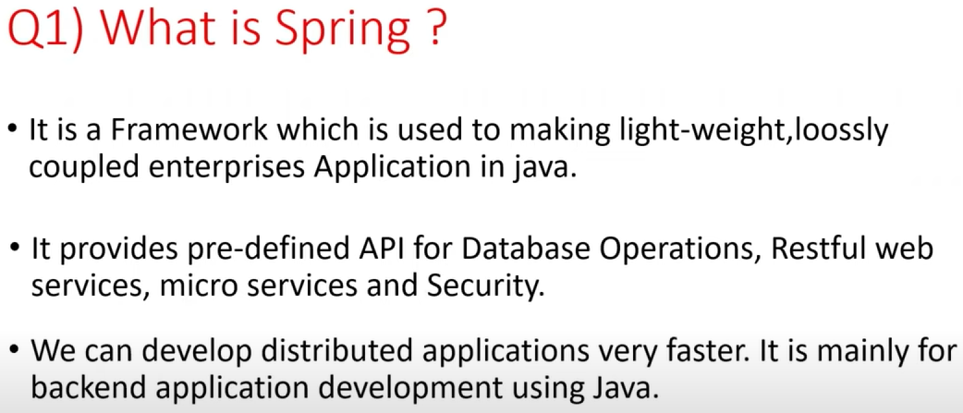

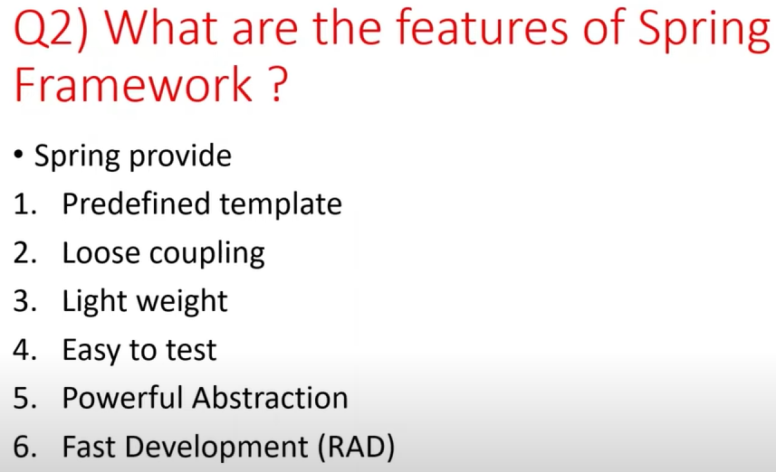

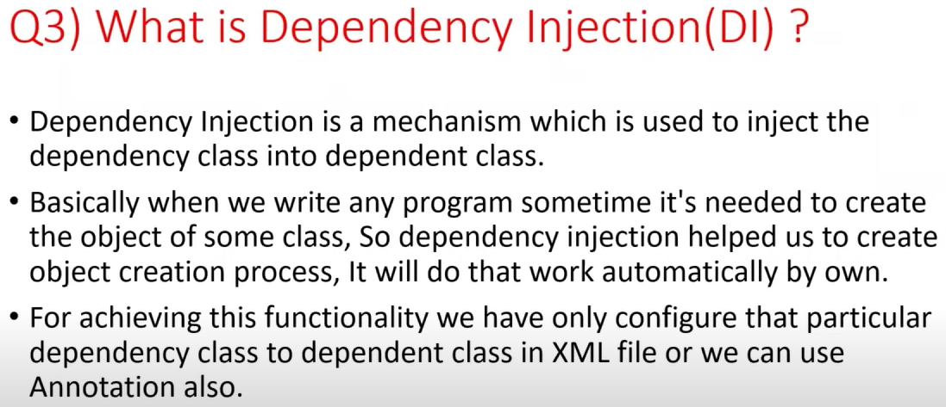

Also called as Manifest or meta files

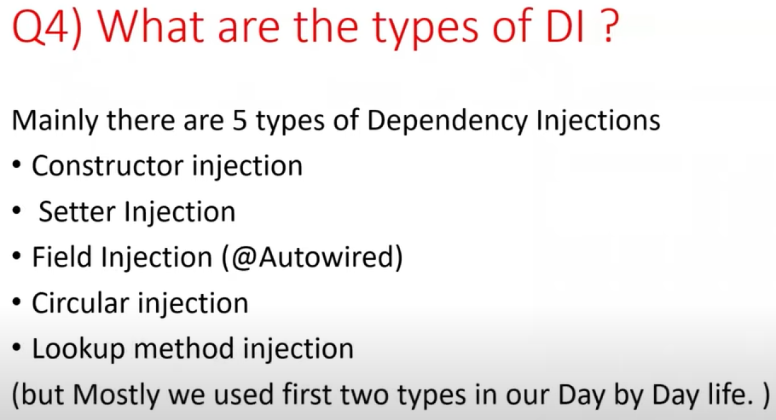

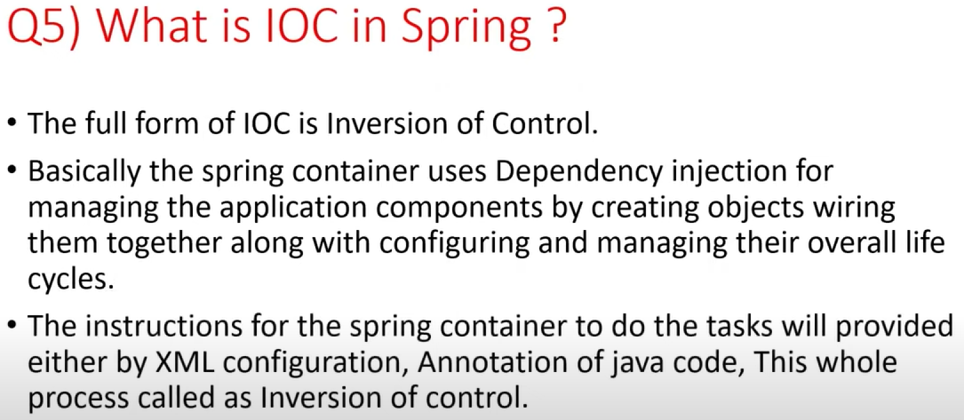

Spring IoC (Inversion of Control) Container is the core of Spring Framework. It creates the objects, configures and assembles their dependencies, manages their entire life cycle. The Container uses Dependency Injection(DI) to manage the components that make up the application.

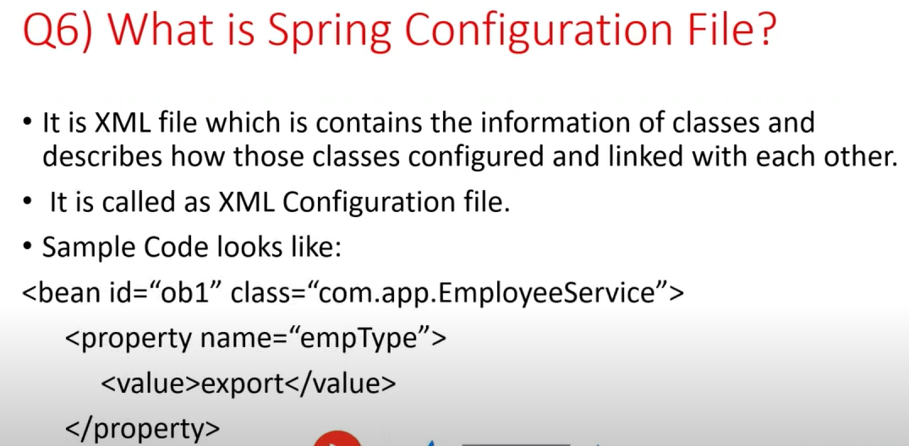

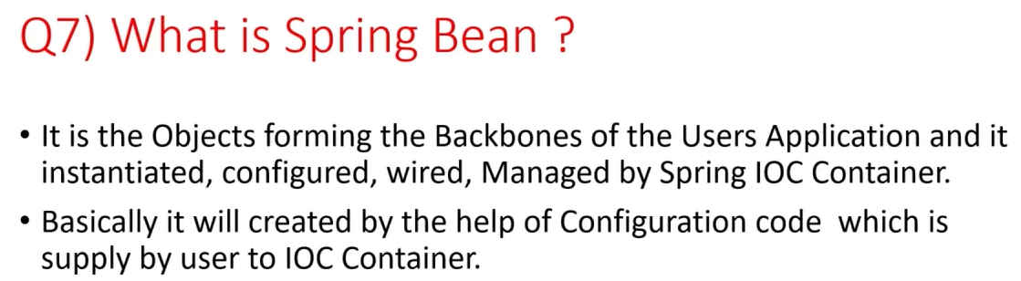

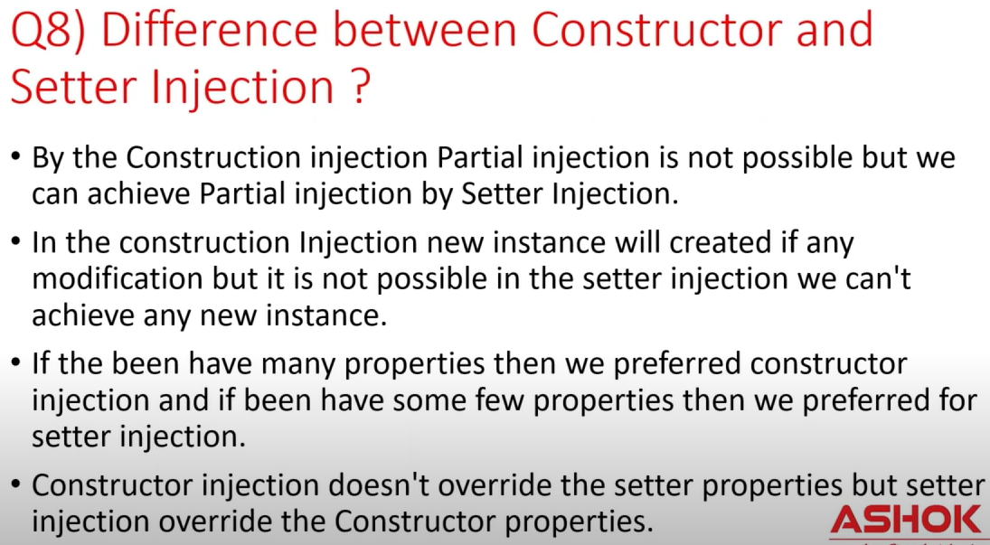

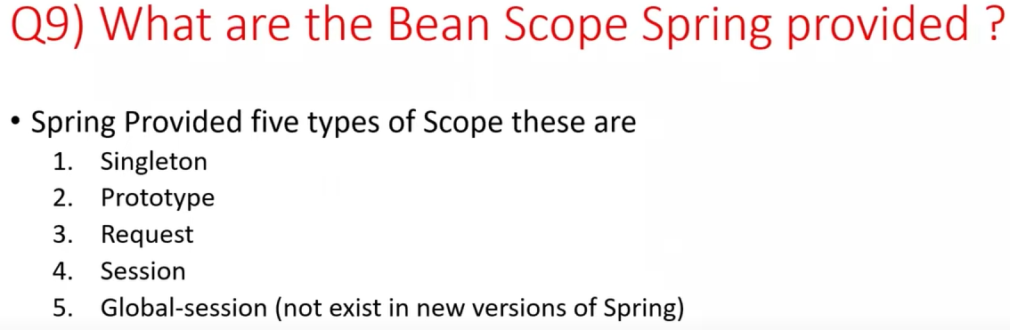

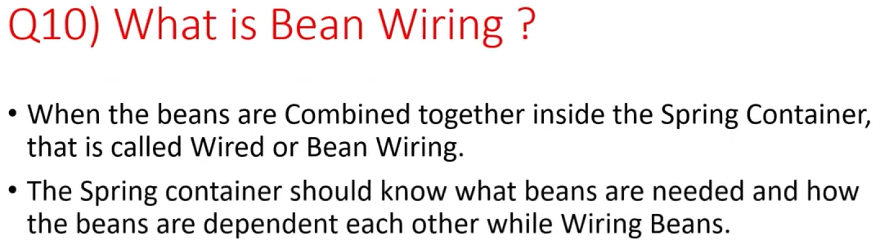

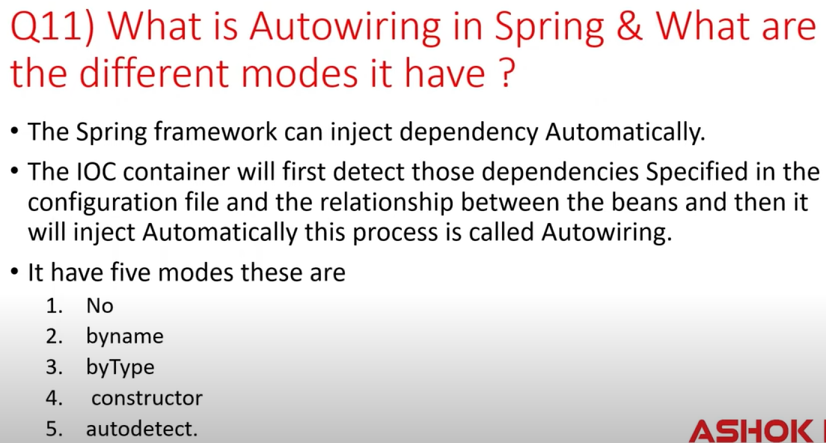

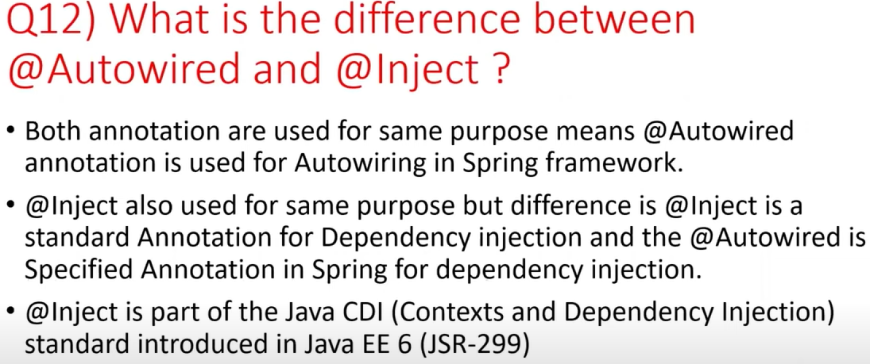

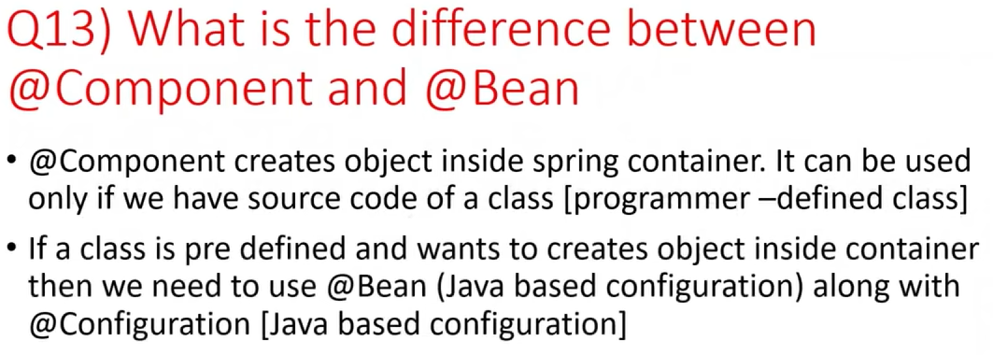

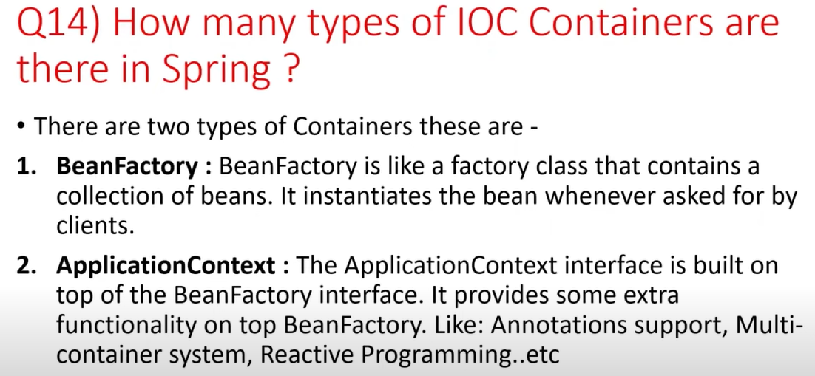

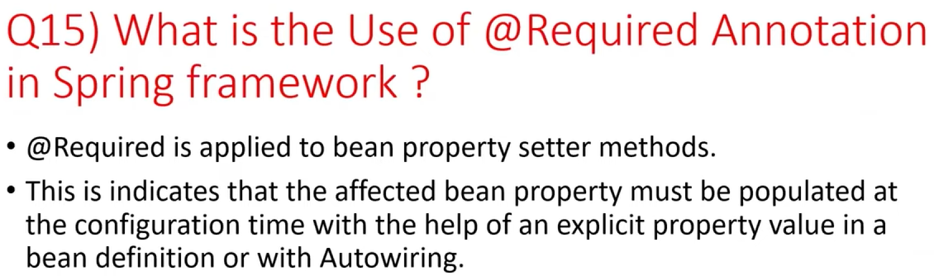

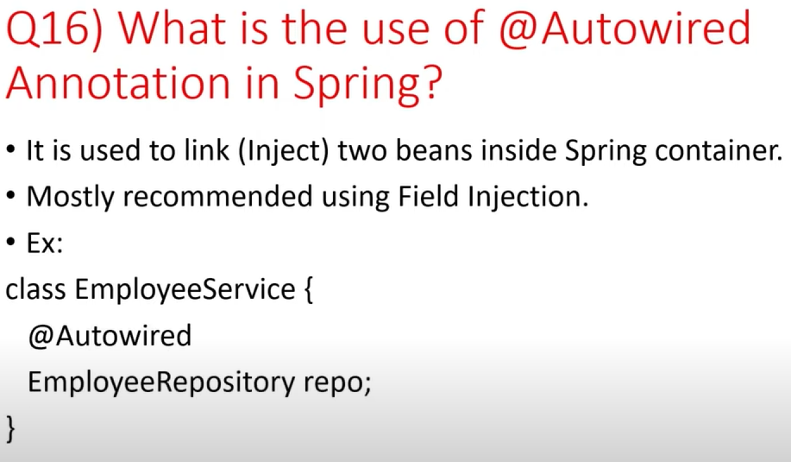

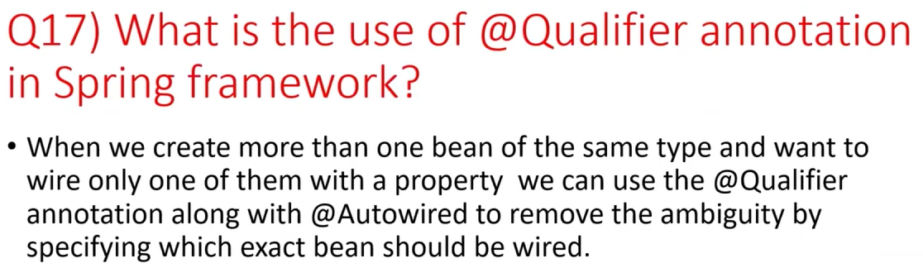

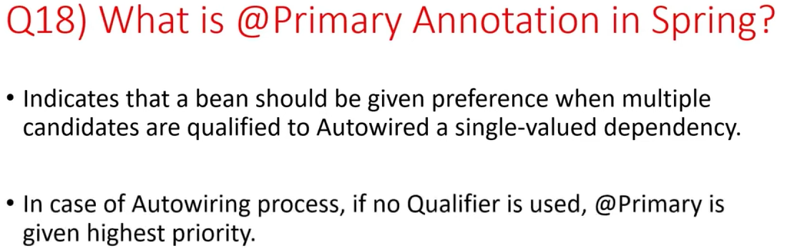

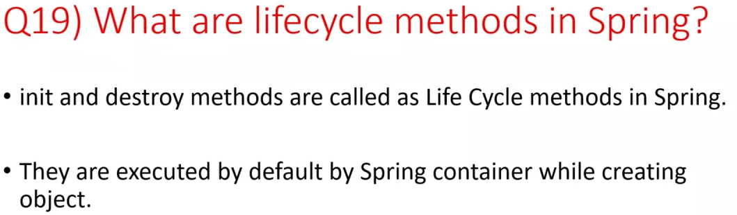

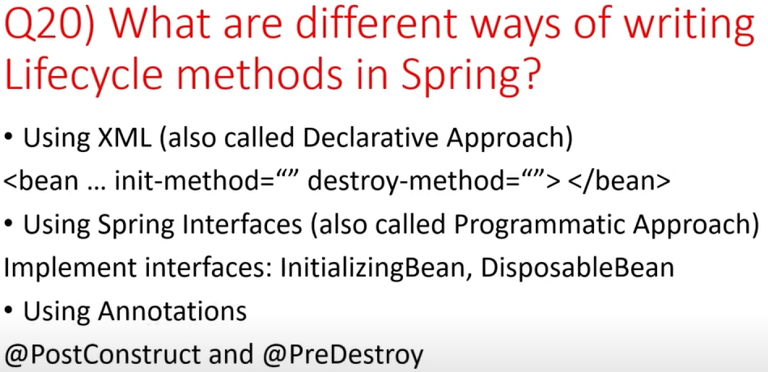

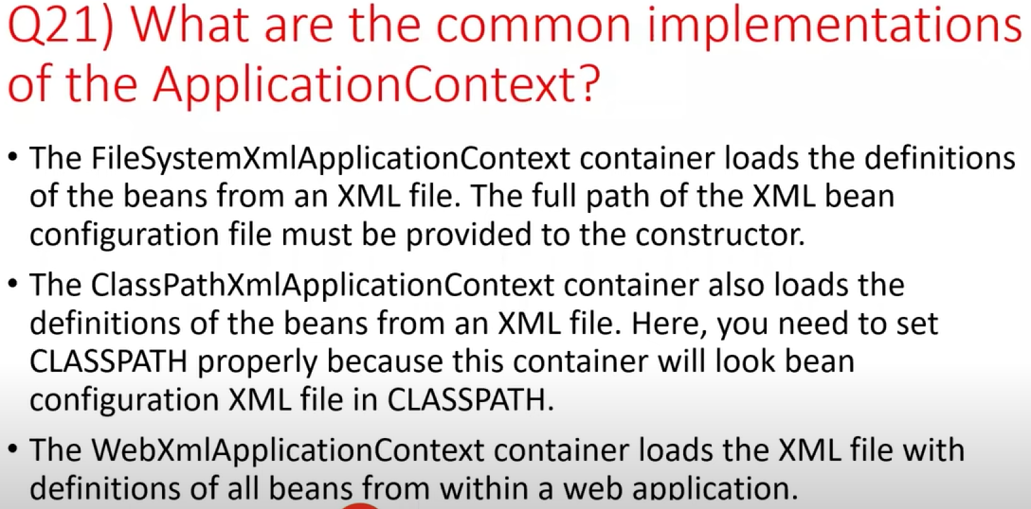

String Builder & String Buffer

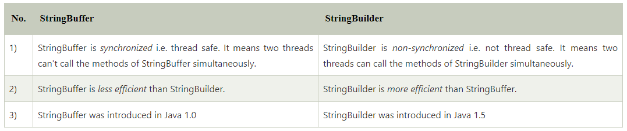

Callable or Runnable

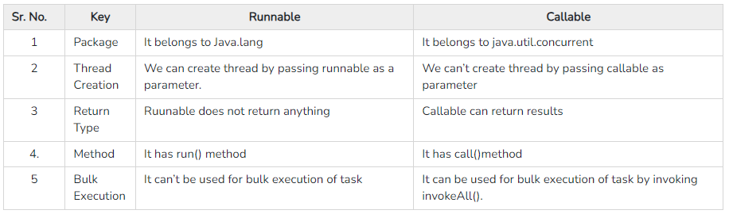

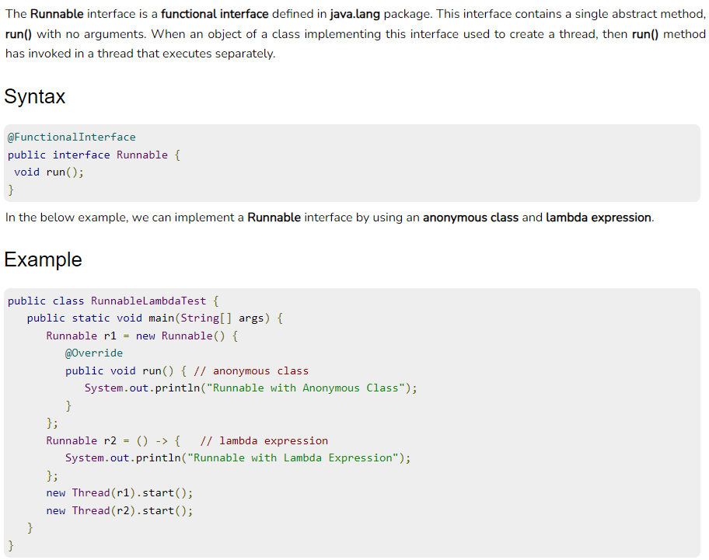

Multi Threading & States of Thread

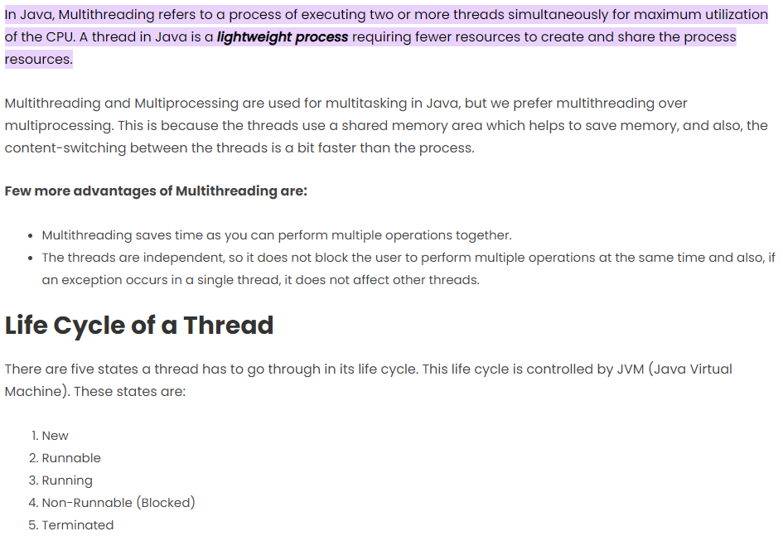

Constructor

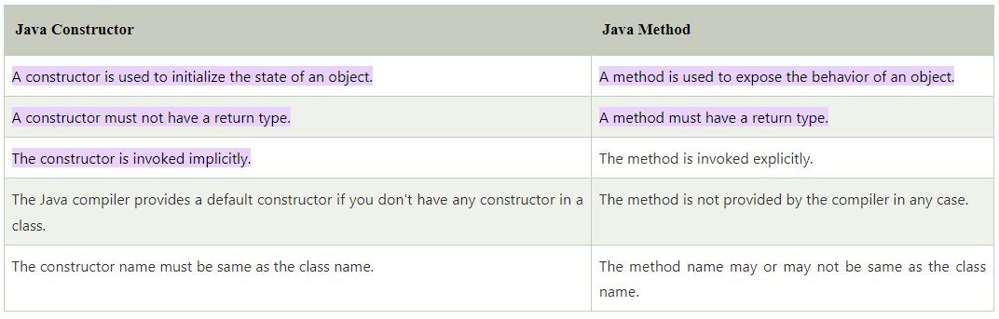

Fail safe & Fail fast exceptions

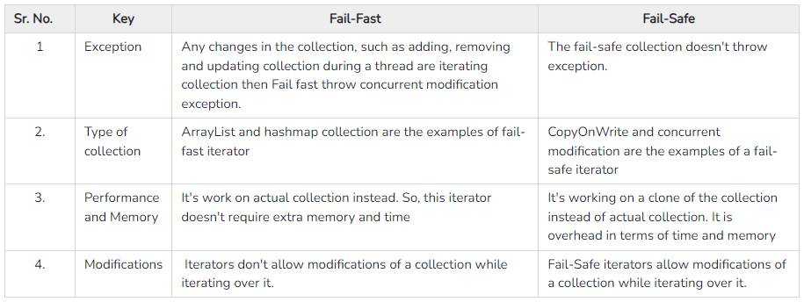

Iterator

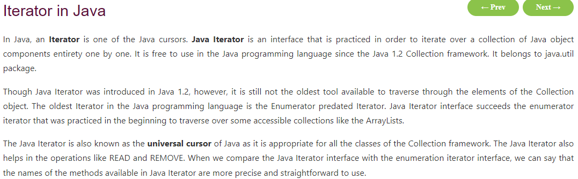

Pass by value & pass by Reference ?

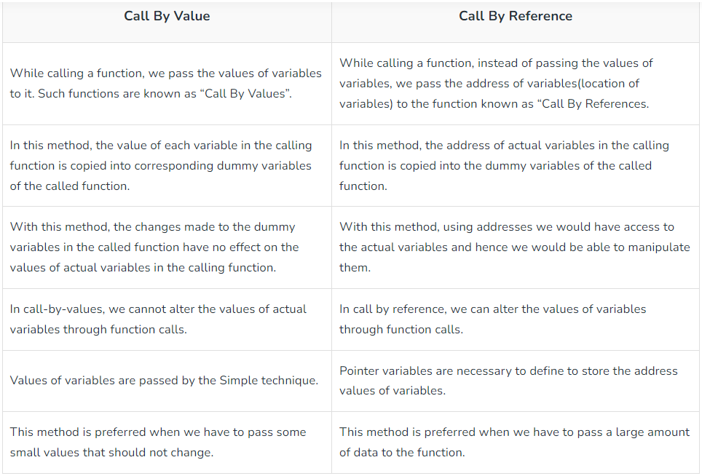

Throw vs throws

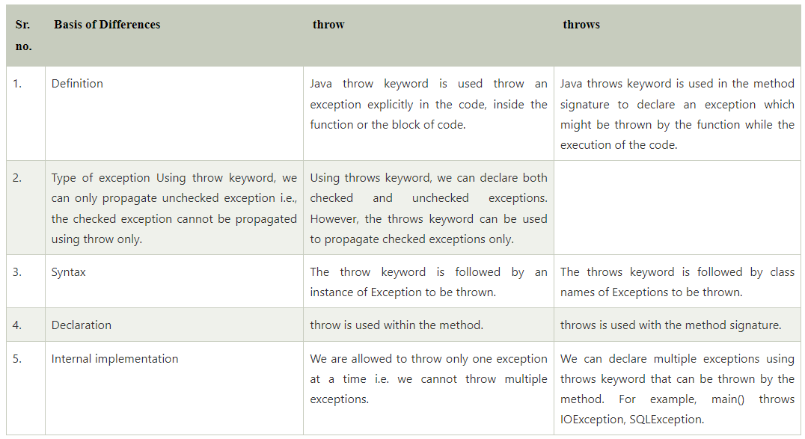

* @Repository: This is a Spring Annotation to indicate that this component handles storing data to a data store.
* @Transactional: Spring annotations are used to simplify transaction management.
* @PersistenceContext: A persistence context handles a set of entities which hold data to be persisted in some persistence store (e.g. a database). In particular, the context is aware of the different states an entity can have (e.g. managed, detached) in relation to both the context and the underlying persistence store.
* EntityManager : The interface is used to interact with the persistence context.
* entityManager.persist(user): Make user entity instances managed and persistent, i.e., saved to the database.
* entityManager.createNamedQuery: It creates an instance of TypedQuery for executing a Java Persistence query language named query. The second parameter indicates the type of result.

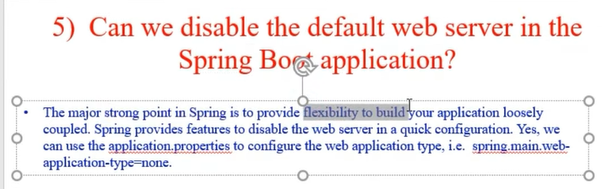

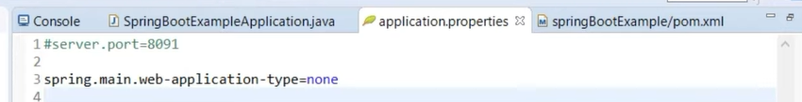

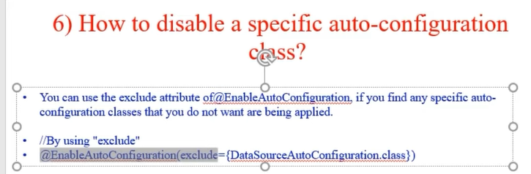

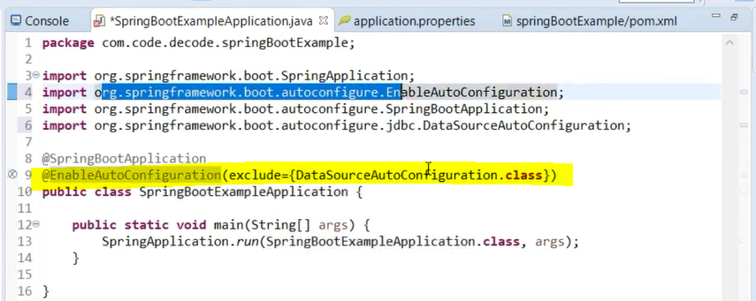

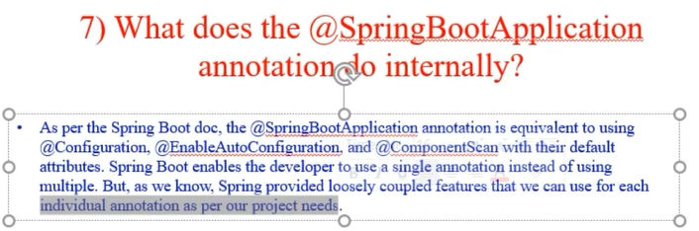

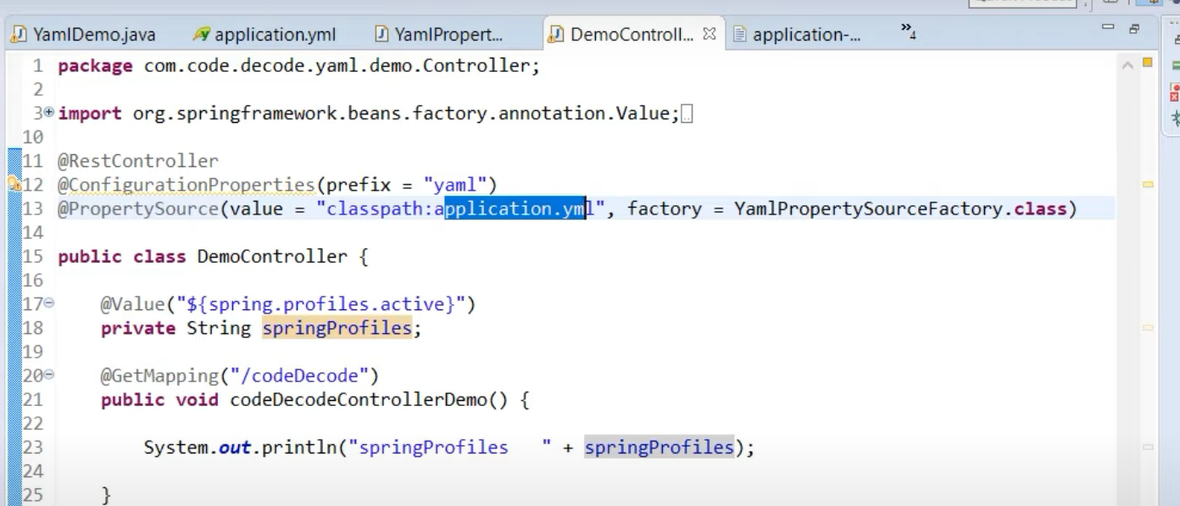

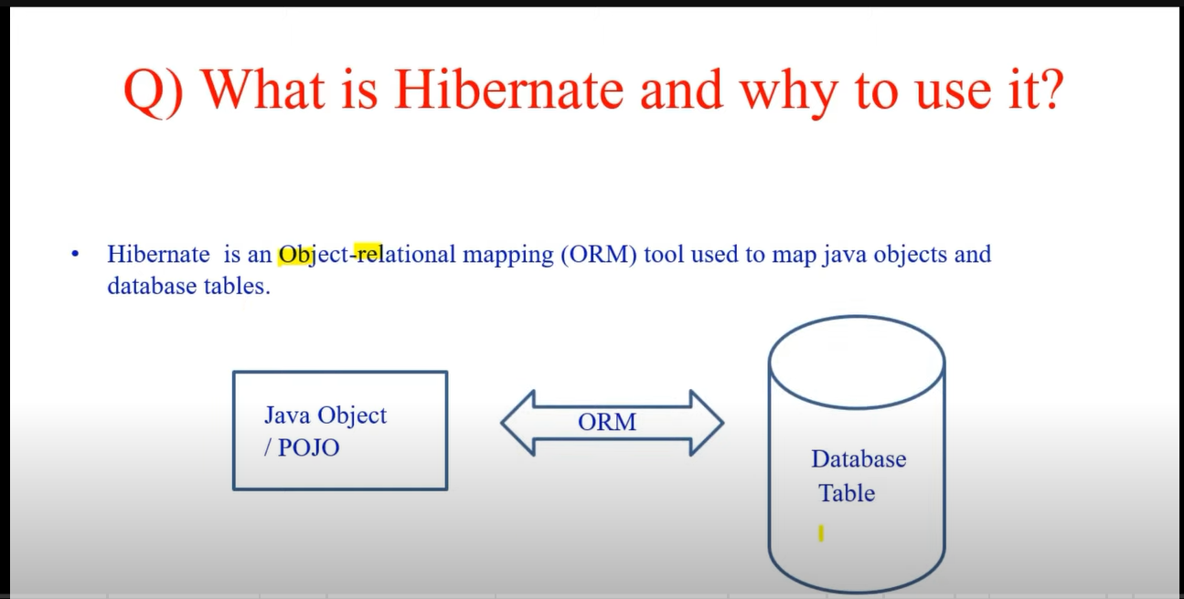

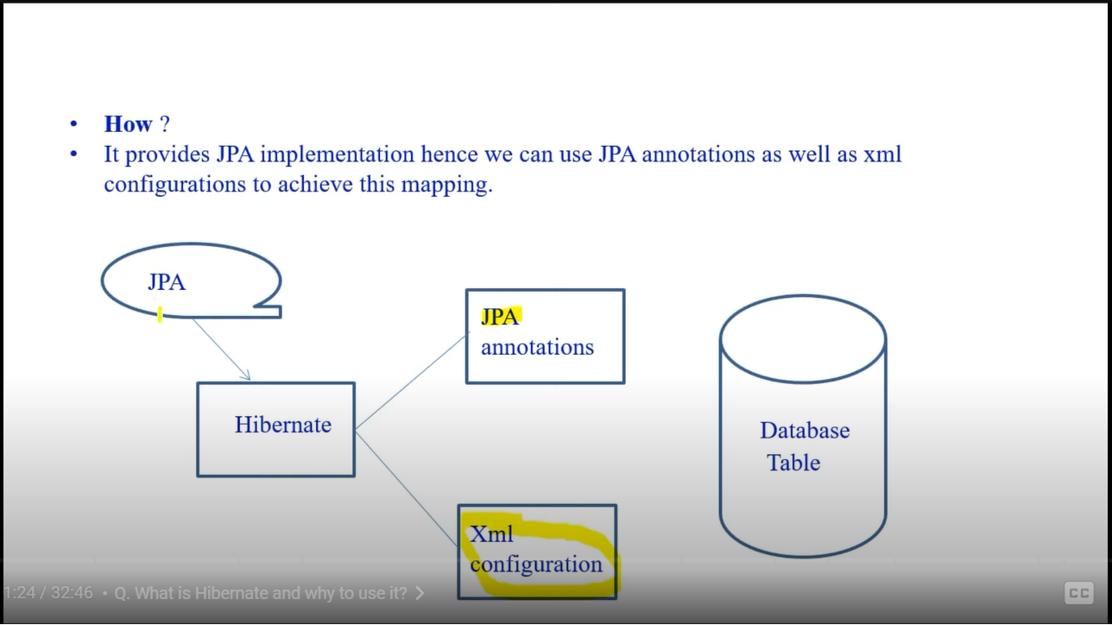

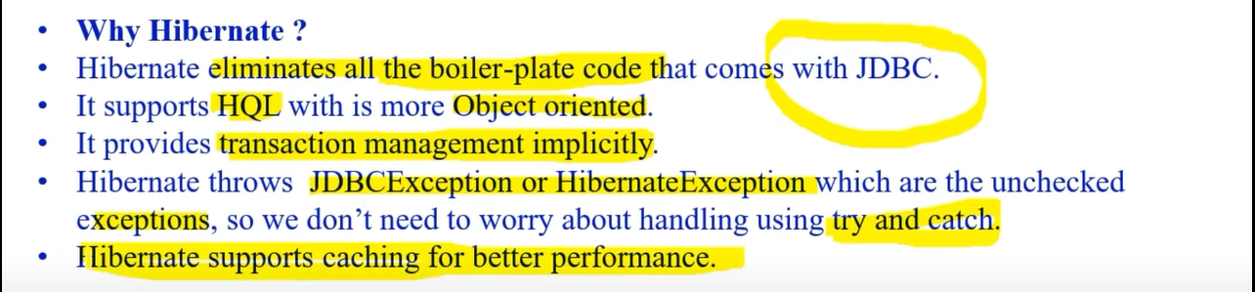

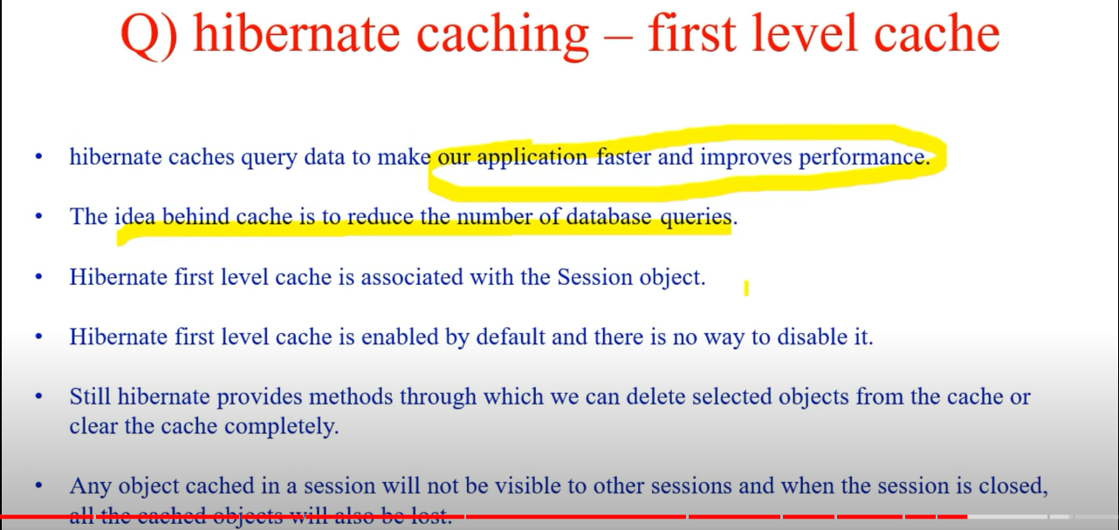

Actuator EndPoints

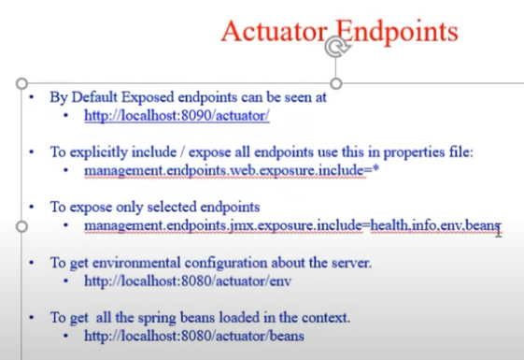

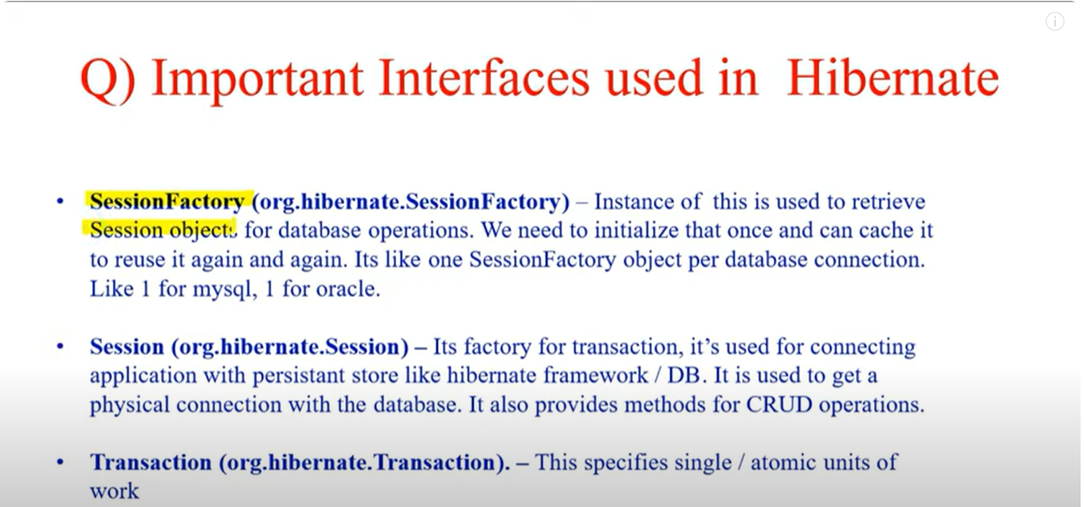

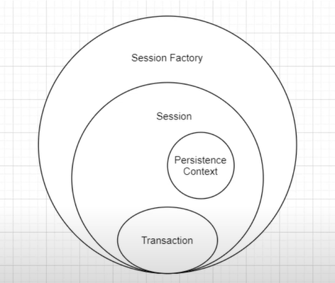

**Transaction in Hibernate:**

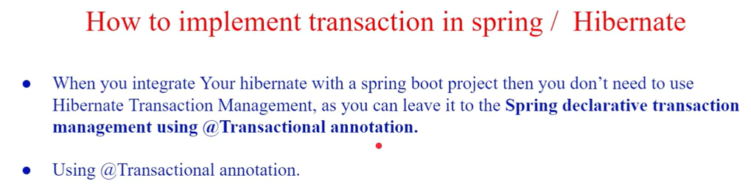

**@Transactional 🡪 will add data to DB only at the end before closing } of method. Till then transaction will be held at memory.**

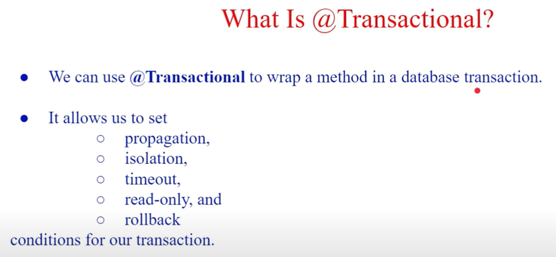

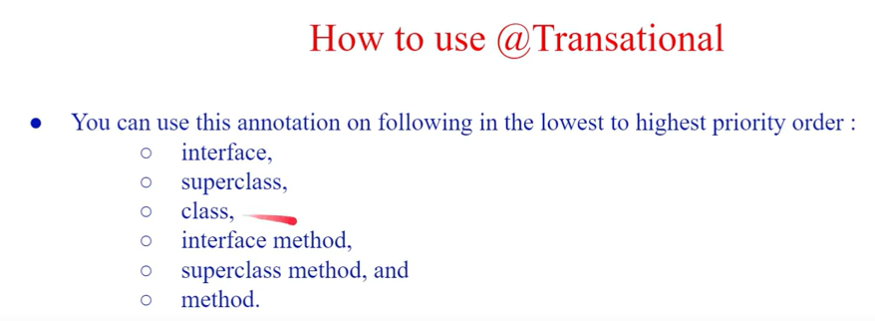

When ever a new data is inserted, it will be in new state under transaction. Once it is saved to DB, it will moved to managed state and then it can be retrieved from session (where no SQL queries are printed).

**3 States of Hibernate:**

Transient

Persistent

Detached

Design Patterns

https://www.javatpoint.com/design-patterns-in-java

Java 8 Features

ACID / Atomicity - > SQL Transactional Roll Back

**Singleton**

In Java, a singleton class is a class that allows only one instance of itself to be created and provides a global point to this instance.

1. Create private static –(return type 🡪 same class – variable name = class name)
2. Empty constructor
3. public static method needs to be created to get current instance, if null it will create.

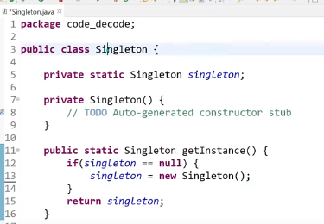

# How to break a singleton class 🡪 Reflection | serialization | Cloning

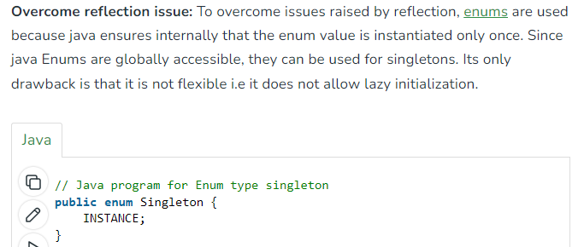

When to use Map & Flat Map ?

Map should be used in streams to fetch single field (getting emails from employee table – one to one relationship)

FlatMap should be used one to Many scenarios for example if one having morethan one record for contact numbers – to fetch the list of fields.

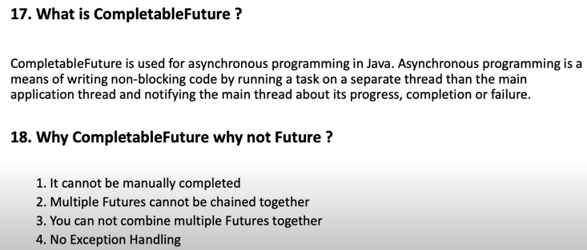

Methods in Completable Future

1. RunAsync
2. SupplyAsync
3. Join
4. thenApply

### **What is Reactive Programming?**

Reactive programming is a programming paradigm that focuses on handling streams of data and events. This programming paradigm uses asynchronous and non-blocking code to handle data streams, making it more efficient and scalable. Reactive programming is based on the idea of reacting to events instead of blocking and waiting for them.

***Exceptions***

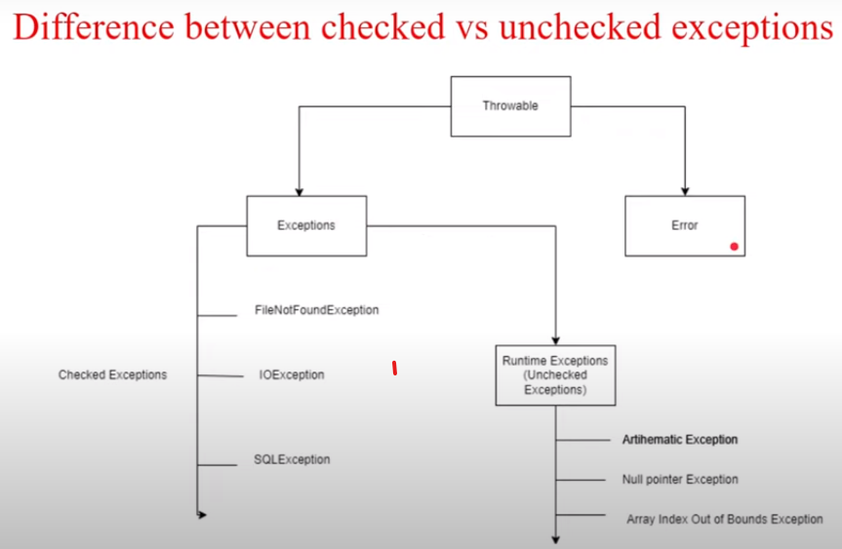

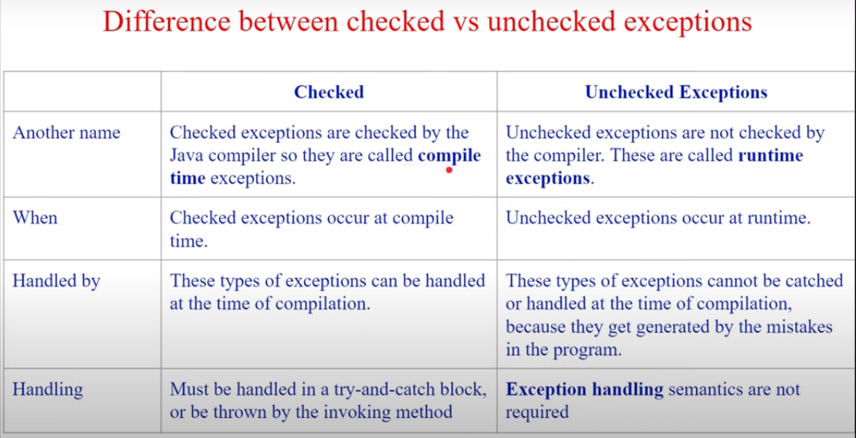

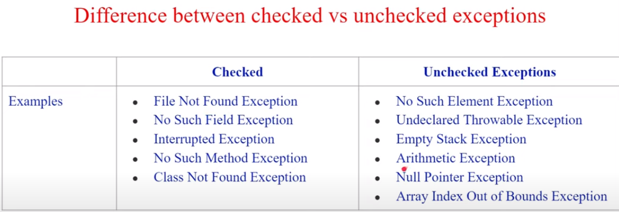

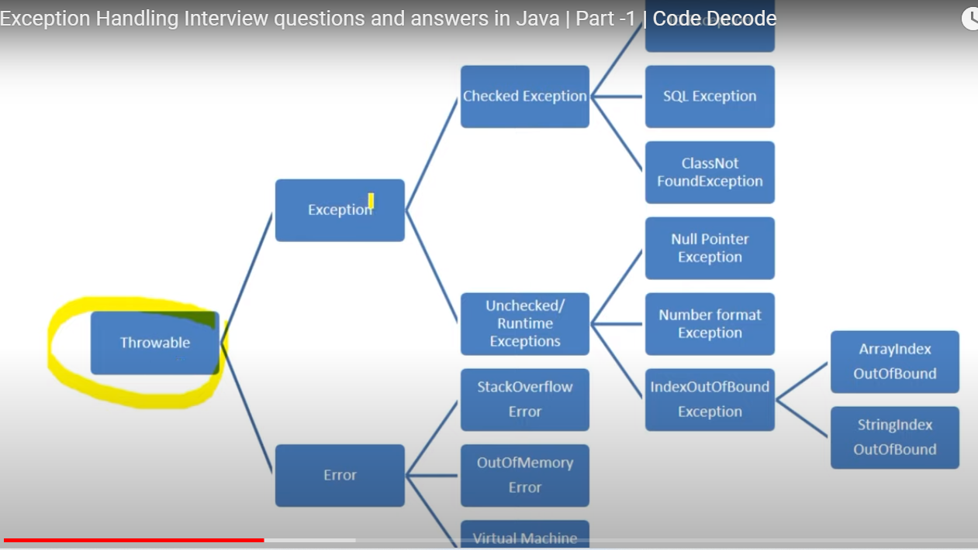

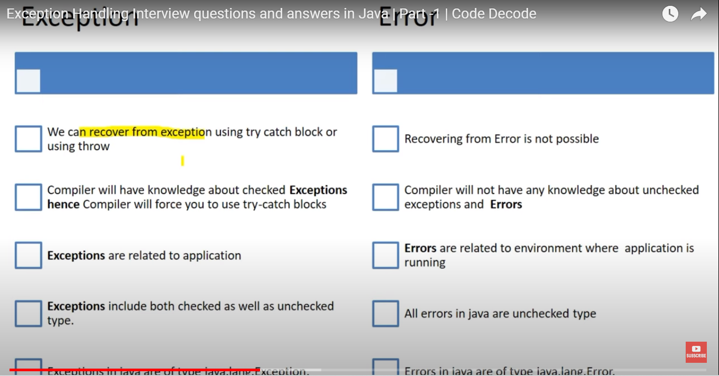

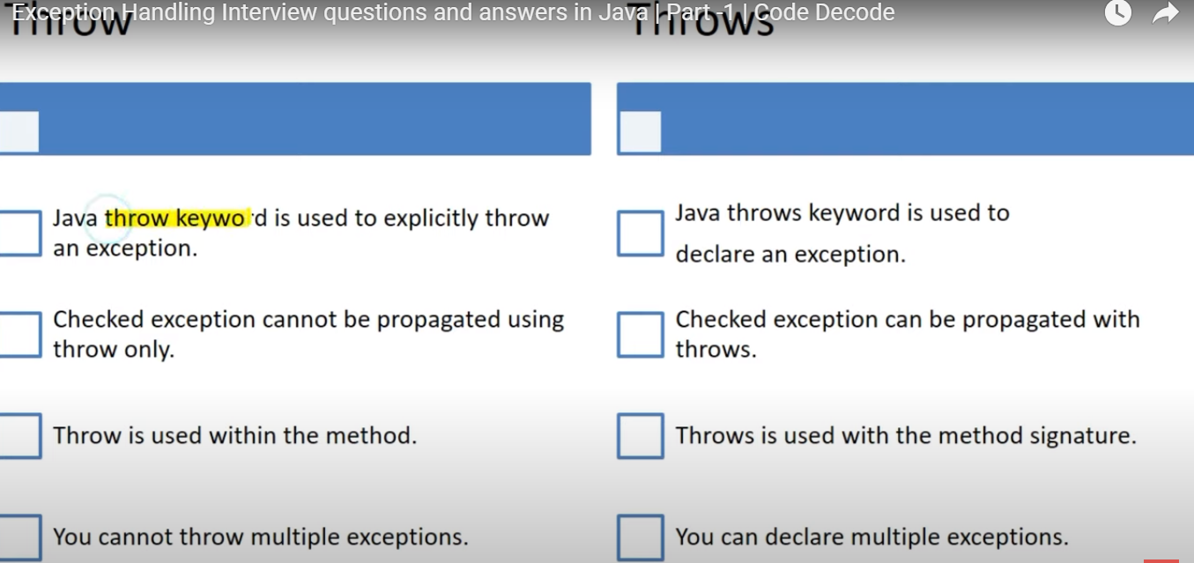

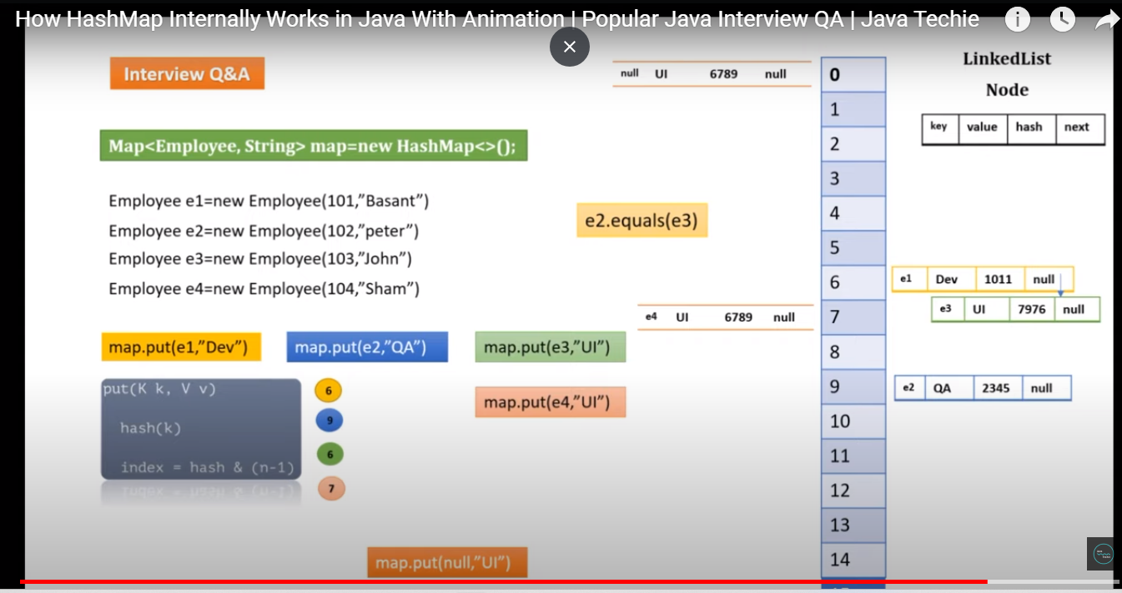

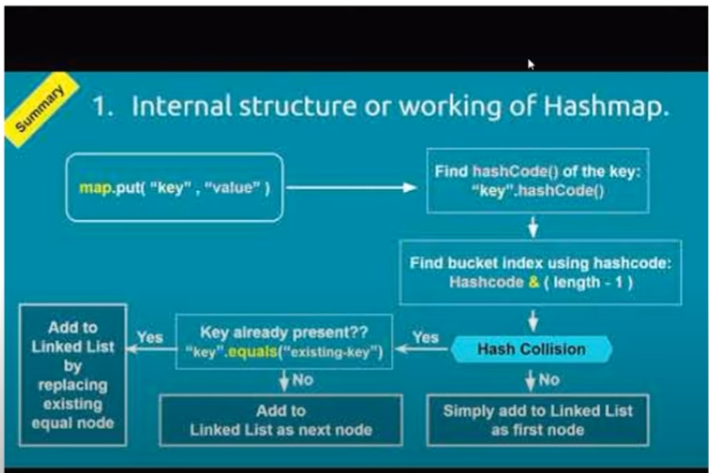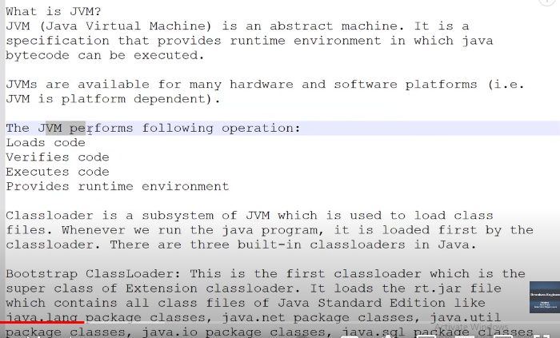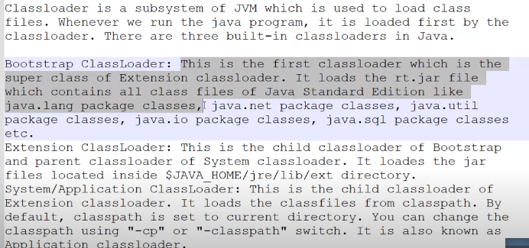

How to make a class immutable in java?

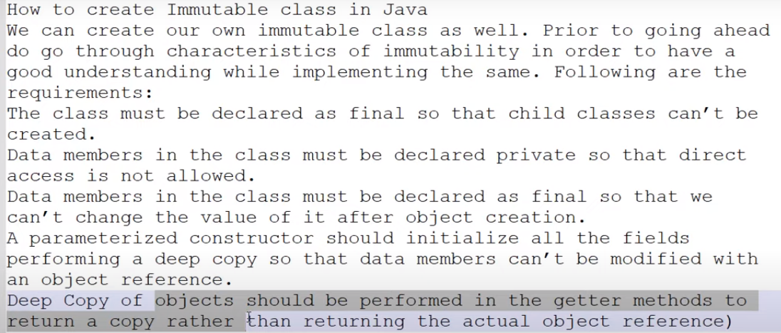

HashMap vs Concurrent HashMap

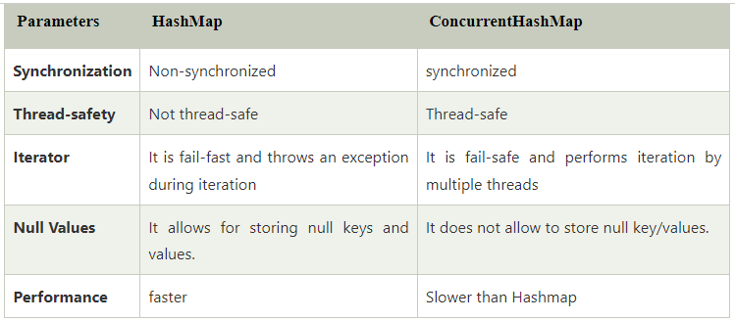

**Hibernate Life Cycle – States:**

<https://www.javatpoint.com/hibernate-lifecycle>

